Database SQL Project

**Description of the Application:**

The database I have chosen to create is that of an online version control system. Examples of this kind of system include GitHub, GitLab, BitBucket, Azure DevOps and Apache Subversion.

The system has a number of users. Each user can own any number of repositories. Each repository contains a branch or multiple branches. Each branch is made of a commit or number of commits, where each commit is made of multiple changes. Users can comment on commits. The following table descriptions will include “PK” for primary key and “FK” for foreign key.

A user is required to have a unique username (PK), a display name (if they wish), an email (for account verification), a description of their account (which may be an empty string), and the date and time they signed up.

Each repo has a unique identifier number (PK), **the** **name of the user who owns the repo** (FK), the date and time the repo was created, a name that is unique to the user (ie the user cannot have multiple repos with the same name) and a boolean value denoting if the repo is public or private.

A branch has a unique ID(PK), the date it was created, a name, **an associated repo** (FK), a description of the branch and **the ID of the latest commit** (FK).

Each commit has a unique ID(PK), **the branch it belongs to** (FK), a comment, a title and the date/time it was created.

A change has a unique identifier (PK), the name of the file that was changed, the old file (stored as a blob), the new file (also stored as a blob) and **the commit this change was created on** (FK).

A comment has a unique ID (PK), **the name of the user that made the comment** (FK), some text and **the change that is being referenced** (FK).

**Entity Relationship Diagram**

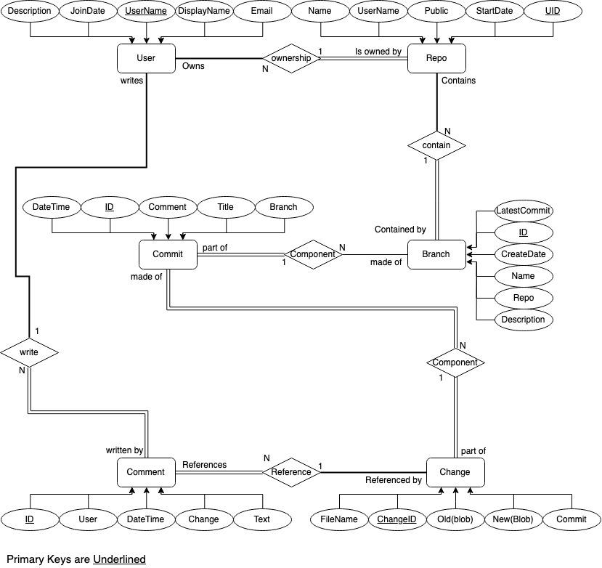

**Relational Schema**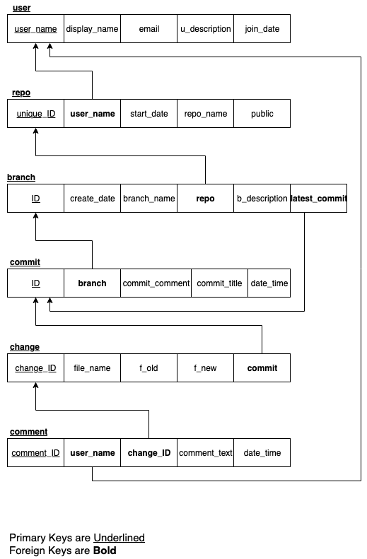

**Functional Dependency**

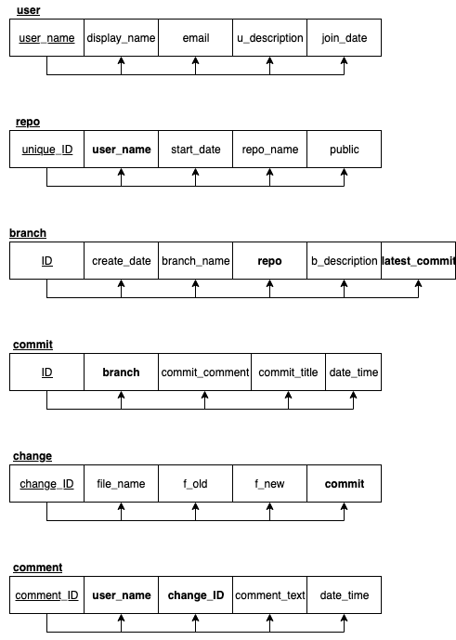

**Semantic Constraints:**

NOT NULL, UNIQUE

**Trigger:**

Add commit -> update latest commit --done

Create repo, check if user already has repo with same name --done

All timestamps take database time --done

**Security:**

Private repos only viewable by owner

**View:**

Each user can only see their repos and public ones

**Appendix:**